
Nama :_____________________
Nomor :_____________________
Kurikulum Merdeka

PEMERINTAH KABUPATEN TULUNGAGUNG
DINAS PENDIDIKAN
SUMATIF TENGAH SEMESTER (STS) I SEKOLAH DASAR
SD NEGERI 4 DEMUK
TAHUN PELAJARAN 2026/2027
Mata Pelajaran : Bahasa Inggris Kelas : VI (enam)
Hari, Tanggal : Rabu , 30 September 2026 Waktu : 10.00 - 11.30 (90 menit)

Petunjuk Pengerjaan Soal
- Bacalah perintah soal!
- Jika jenis soal pilihan ganda, berilah tanda silang pada huruf A, B, C, atau D pada jawaban yang benar!
- Jika jenis soal isian jawablah dengan benar!
- Jika jenis soal uraian jawablah dengan benar!

- Choose the right answer!
The text is for number 1 – 5
Holiday Trip
Last holiday, my family and I went to the beach. We left home early in the morning. My father drove the car, and my mother prepared some food and drinks.
We arrived at the beach at nine o’clock. The weather was sunny and beautiful. My brother and I played with the sand and collected some shells. After that, we swam in the sea with our parents.
At noon, we had lunch under a big tree. We ate fried rice, chicken, and fruit. After lunch, we took some pictures together. We were very happy. In the afternoon, we went home. It was a wonderful holiday. I really enjoyed the trip with my family.
- Where did the writer go last holiday?
- To the zoo C. To the mountain
- To the beach D. To the museum
- What time did they arrive at the beach?
A. At seven o’clock C. At nine o’clock
B. At eight o’clock D. At ten o’clock
- What did the writer and his/her brother collect?
A. Flowers B. Stone C. Leaves D. Shells
- What did the family eat for lunch?
A. Noodles and soup C. Bread and milk
B. Fried rice, chicken, and fruit D. Fish and vegetables
- How did the writer feel about the holiday?
A. Sad B. Angry C. Happy D. Bored
- Last night, I . . . early because I was tired.
A. sleep B. sleeps C. slept D. sleeping

- A : “What did Rino do yesterday?”
B : “He . . . in the swimming pool.”
- swim B. swam C. swims D. swimming
- My sister . . . English last night.
- study B. is studying C. was studying D. studied
- Last Sunday, my family . . . to Gemah beach but we went to Molang beach.
A. didn’t go B. didn’t buy C. didn’t eat D. didn’t sleep
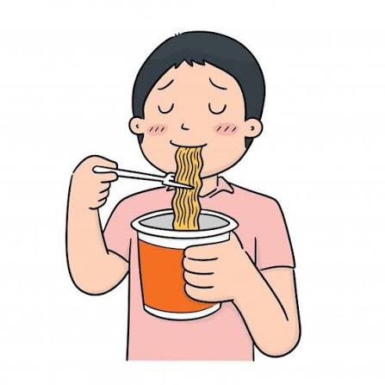
- A : “Did Andi read a storybook in his bedroom?”
B : “ . . . .”
A. Yes, he did C. No, he didn’t
B. Yes, he is D. No, he isn’t

- Fill in the blanks with the correct words!
- We swam in the lake during our holiday last week. The underlined words mean . . . .

- Siti ate a delicious cake . . . (kemarin).
- A : “Where was Siska last night?”
B : “She . . . in the hospital.”

- A : “When did you go to the zoo?
B : “I went to the zoo . . . ( dua hari yang lalu).”
- A : “Where were Lala and Lilo yesterday?
B : “They . . . in the library.”
- My brother . . . (menonton) movie two days ago.
- Mother . . . (tidak memasak) dinner last night.
- We . . . to music yesterday afternoon. (listen)
- Siti . . . beautifully at the party last Saturday. (dance)
- Indra . . . in the mosque yesterday. (was/were)
- They . . . at school yesterday morning. (was/were)
- Tiga tahun yang lalu in English is . . . .
- They . . . (minum) watermelon juice last morning.
- Three weeks ago in Indonesian is . . . .
- My sister . . . (tidak makan) fried rice yesterday.
- Last month in Indonesian is . . . .
- Andi: “Did you play football last Sunday?
Budi: “Yes, . . . .
- Rudi: “Where did you go last weekend?”

Tono: “I . . . to the beach with my family.”
- Lina: “What did your father do last night?”
Dina: “He . . . fried rice.”


- Doni: “What did your sister do yesterday?”
Rani: “She . . . a book in her bedroom.”

The text is for number 26 - 30
My Holiday
Last Sunday, I went to my grandmother’s house with my family. We left home at seven o’clock in the morning. We arrived at her house at eight o’clock.
My grandmother welcomed us happily. I helped her cook lunch in the kitchen. My brother played football with our cousins. After lunch, we talked and watched television together.
In the afternoon, we went home. I was very happy because I spent a wonderful day with my family.
- Last Sunday, I . . . to my grandmother’s house.
- We . . . home at seven o’clock in the morning.
- I . . . my grandmother cook lunch.
- My brother . . . football with our cousins.
- I . . . very happy because I spent a wonderful day with my family.

- Answer these question with the right answer!
- Change the sentence into Indonesian!
I played football with my friends the day before yesterday.
Answer : .............................................................................................................................................
...............................................................................................................................................
- Change the sentence into English!
Ke mana Indra pergi hari Minggu lalu?
Answer : ..............................................................................................................................................
.............................................................................................................................................
- Change the sentence into a negative sentence!
They watched a movie last night.
Answer : ..............................................................................................................................................
.............................................................................................................................................
- Change the sentence into an interrogative sentence!
Rina went to the library yesterday.
Answer : ..............................................................................................................................................
.............................................................................................................................................
- Write 3 sentences about what you did yesterday. Use Simple Past Tense!
Answer : 1...............................................................................................................................................
- .............................................................................................................................................
- ..............................................................................................................................................

